Miyazaki International College
Spring 2019

Course Title ( Credits ) | JESC-1 Studies in Japanese Expression C (1 credit)
Course Designation for TC | None TC
Content Teacher
Instructor(s) | none
E-mail address
Office/Ext
Office hours
Language Teacher
Instructor(s) | Maeda/Jun
E-mail address | jmaeda@sky.miyazaki-mic.ac.jp
Office/Ext | 2-105/780
Office hours | 3:00pm – 5:00pm (Tue., Thurs.)

Course Description:
This course will be coordinated with Japanese Expression 4 to deepen studies in written expression, and offer practical activities for enhancing one’s ability to express and communicate.
Course Goals/Objectives:
To acquire Japanese writing skills through translating a few chapters of ‘The Art of Worldly Wisdom’ of Balthasar Gracian.
Course Schedule
No/Week/Day | Topic | Content
1st week | introduction | About the textbook, syllabus, coursework assignment
2nd | Presentation and question/answer | Presentation (page 1)
3rd | Presentation and question/answer | Presentation (page 2), Presentation (page 3)
4th | Presentation and question/answer | Presentation (page 4), Presentation (page 5)
5th | Presentation and question/answer | Presentation (page 6), Presentation (page 7)
6th | Presentation and question/answer | Presentation (page 8), Presentation (page 9)
7th | Presentation and question/answer | Presentation (page 10), Presentation (page 11)
8th | Presentation and question/answer | Presentation (page 12), Presentation (page 13)
9th | Presentation and question/answer | Presentation (page 14), Presentation (page 15)
10th | Presentation and question/answer | Presentation (page 16), Presentation (page 17)
11th | Presentation and question/answer | Presentation (page 18), Presentation (page 19)
12th | Presentation and question/answer | Presentation (page 20), Presentation (page 21)
13th | Presentation and question/answer | Presentation (page 22), Presentation (page 23)
14th | Presentation and question/answer | Presentation (page 24), Presentation (page 25)
15th | Presentation and question/answer | Presentation (page 26)
Final Exam | Final Examination
Required Materials:
Textbook: The Art of Worldly Wisdom by Balthasar Gracian (text to be provided)
Course Policies (Attendance, etc.)
Presentation Handout: The student in charge of the day’s presentation is required to provide a presentation handout for the class. The handout must contain (1) meanings of difficult words, (2) interpretations of difficult phrases and (3) two or three questions the student comes across while translating the passages. Essay Writing: After the presentation the student writes an essay of about 1000 letters in Japanese and turns it in to the instructor in the next class session. Homework Assignments: Essays and other writing assignments must be: with title of the essay, with student name, double-spaced, horizontally-typed, on one sheet of A4 paper, in not smaller than 10 points of Font size and in 明朝体／ゴシック体 of Font type. Student Consultation: The instructor is available any time he is in the office, but by appointment preferred. Late Submission of Homework Assignments: In case a student fails to submit an assignment by the deadline, he/she has to turn in the assignment to the instructor by 5:00pm of the same day. Failure to do so will lower the grade. Attendance: If a student is 5 minutes+ late for the class, it will be counted as absence and not as tardiness. The same rule is applied if s/he leaves the class 5 minutes+ earlier before it ends. Absence: A student will not be entitled to ask for the credit for the course if s/he miss more than one fourth of the class sessions offered in the semester, (i.e. 3+,) even if his/her total grading score is over 60.

Course preparation and Review
To read the text and think about how the translation should be done at least 30 minutes every day.
Grades and Grading
Presentation (translation) 20%
Handout (translation) 20%
Essay (translation) 20%
Presentation/interaction (question/s) 10%
General Participation in class activities (all students) 10%
Text booklet 10%
Final Examination 10%
…………………………………………………………………………………………………………………………………………………………………………………………………
Total 100%
Methods of Feedback:
The instructor gives comments on student performance and his/her handout in class.
Diploma Policy Standards Satisfied by Course Objectives:
- Advanced thinking skills (comparison, analysis, synthesis, and evaluation) based on critical thinking (critical and analytic thought)
- The ability to understand and accept different cultures developed through acquisition of a broad knowledge and comparison of the cultures of Japan and other nations
- The ability to identify and solve problems
Note:
Text Booklet: The students submit to the instructor the text booklet on July 31 (the day of Final Examination) after the examination. The instructor returns the text booklets to the students later. Food and Drink: Neither eating nor drinking is allowed during the class session.

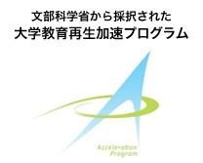  Japanese  Expression A |  | 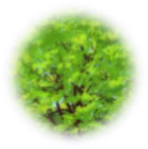  Advanced | 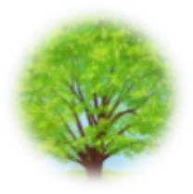  Proficient | 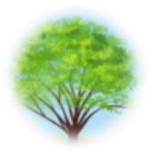  Developing  Spring 2018 | Emerging | No Attempt
Jpn. Lang. Ability | Reading | Shows enthusiasm for reading the material | Is a diligent reader of the material | Shows interest in reading the material a little | Shows little interest in reading the material | No attempt observed
 | Writing | Shows enthusiasm for expressing one’s idea in writing | Shows some enthusiasm for  expressing one’s idea in writing | Shows some interest in  expressing one’s idea in writing | Shows little interest in  expressing one’s idea in writing | No writing assignments turned in
 | Oral Communication | Ardent verbal interaction  on the topic  observed in class | Active verbal interaction on the topic  observed in class | Some verbal interaction  on the topic  observed in class | limited verbal interaction on the topic  observed in class | Very limited verbal  interaction on the topic  observed in class

